## **** Css assignment

1• What are the benefits of using CSS?

Ans: .1 Better Website SpeedFor a website to function efficiently, it should have a faster load time. In modern times, people usually wait for just a couple of seconds for a website to load. So, it’s important to ensure faster speed. For companies wanting to ensure a faster and smooth website experience, CSS becomes paramount to their success.

2.Easier to MaintainCSS is easy to maintain due to less maintenance time. This is because a single line code change affects the entire web page. Also, if improvements are required, then less effort is required to affect changes in the webpage code.

3.Consistent DesignYou would have seen many websites that are elegant and user-friendly. One thing common to all these websites is consistency in design. CSS enables developers to ensure the style elements are applied consistently across several web pages.

4.Time-SavingDue to faster speed and easier maintenance, CSS saves a lot of time and effort in the web development process due to faster loading time. Here, lesser time ensures designer efficiency.

5.Better Device CompatibilityPeople use different smart devices to view a particular website. It can be a smartphone, PC or laptop. For this purpose, websites are required to be device compatible. CSS ensures the task is done smoothly by providing better compatibility.  Positioning of Design ElementsYou can change the position of an HTML tag with the help of CSS. You can place the elements like an image on any part of the webpage as and when required.

2• What are the disadvantages of CSS?

### Ans **1. Confusion due to many CSS levels:**Beginners are more vulnerable to this issue. They might get confused while opting to learn CSS as there are many levels of CSS such as CSS2, CSS3, etc.

**2. Cross-Browser Issues:**Different browsers work differently. So, you have to check that changes implemented in the website via CSS codes are reflected properly among all browsers.

**3. Security Issues:**Security is important in today’s world driven by technology and data. One of the major disadvantages of CSS is that it has limited security.

**4. Extra Work for Developers**:Design services are required to consider and test all CSS codes across different browsers for compatibility. Due to developers testing compatibility for different browsers, their workload increases.

Overall, we can say that if you are passionate about web development, try to learn HTML and CSS. For device compatibility, learn the Bootstrap framework as well. Though you might see

3• What is the difference between CSS2 and CSS3?

ans: **New CSS3 Selectors**

16 new pseudo-classes have been introduced:

**:root**

The root element of the document.

**:nth-child(n)**

Use this to match exact child elements or use variables to get alternating matches.

**:nth-last-child(n)**

Match exact child elements counting up from the last one.

**:nth-of-type(n)**

Match sibling elements with the same name before it in the document tree.

**:nth-last-of-type(n)**

Match sibling elements with the same name counting up from the bottom.

**:last-child**

Match the last [child element](https://www.thoughtco.com/css-inheritance-overview-3466210) of the parent.

**:first-of-type**

Match the first sibling element of that type.

**:last-of-type**

Match the last sibling element of that type.

**:only-child**

Match the element that is the only child of its parent.

**:only-of-type**

Match the element that is the only one of its type.

**:empty**

Match the element that has no children (including text nodes).

**:target**

Match an element that is the target of the referring URI.

**:enabled**

Match the element when it's enabled.

**:disabled**

Match the element when it's disabled.

**:checked**

Match the element when it's checked (radio button or checkbox).

**:not(s)**

Match when the element does not match the simple [selectors](https://www.thoughtco.com/what-is-a-css-selector-3467058).

There's one new combinator:

**New Properties**

CSS3 also introduced several new CSS properties. Many of these properties create visual styles that would likely associate more with a graphics program like [Photoshop](https://www.lifewire.com/what-is-photoshop-4688397). Some of these, like border-radius or box-shadow, have been around since the introduction of CSS3. Others, like flexbox or even [CSS](https://www.thoughtco.com/what-is-css-3466390) Grid, are newer styles that are still often considered CSS3 additions.

In CSS3, the box model hasn't changed. But there are a bunch of new style properties that can help you style the backgrounds and borders of your boxes.

**Multiple Background Images**

Using the background-image, background-position, and background-repeat styles, you can specify multiple background images to be layered on top of one another in the box. The first image is the layer closest to the user, with the following ones painted behind. If there is a background color, it is painted below all the image layers.

**New Background Style Properties**

There are also some new background properties in CSS3:

**background-clip**

This property defines how the background image should be clipped. The default is the border-box, but it can be changed to the padding box or the content box.

**background-origin**

This property determines whether the background should be placed in the padding box, the border-box, or the content box.

**background-size**

This property indicates the [size of the background image](https://www.thoughtco.com/responsive-background-images-3467001). It allows you to [stretch smaller images to fit the page](https://www.thoughtco.com/stretch-background-image-3466979).

**Changes to Existing Background Style Properties**

There are also a few changes to existing background style properties:

**background-repeat**

There are two new values for this property — space and round. Space spaces the tiled image evenly within the box without being clipped. Round rescales the background image so that it will tile a whole number of times in the box.

**background-attachment**

A new value "local" is added so that the background will scroll with the element's content when that element has a scroll bar.

**background**

The background shorthand property adds in the size and origin properties.

**CSS3 Border Properties**

In CSS3, borders can be the styles we're used to (solid, double, dashed, etc.) or they can be an image. Plus, CSS3 supports rounded corners. Border images are interesting because you create an image of all four borders and then tell the CSS how to apply that image to your border

4• Name a few CSS style components

For every Angular component you write, you can define not only an HTML template, but also the CSS styles that go with that template, specifying any selectors, rules, and media queries that you need.

One way to do this is to set the styles property in the component metadata. The styles property takes an array of strings that contain CSS code. Usually you give it one string, as in the following example:

5 • What do you understand by CSS opacity?

ANS:

The CSS opacity property is used to specify the transparency of an element. In simple word, you can say that it specifies the clarity of the image. In technical terms, Opacity is defined as degree in which light is allowed to travel through an object.

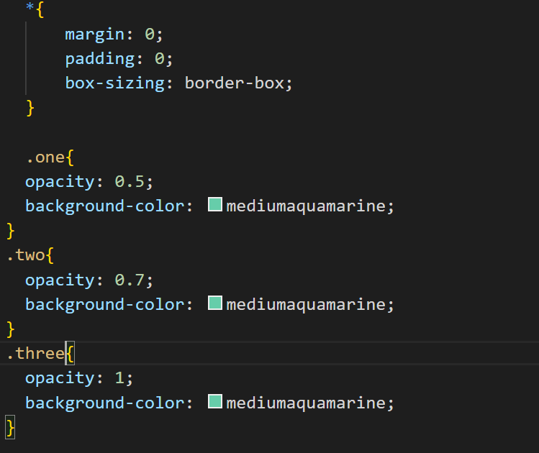

Output: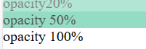

6• How can the background color of an element be changed?

ANS: You can change the background color of an HTML element using the background-color CSS property and giving it a value of a color.

p {background-color: pink;}With this code, the paragraphs are given a pink background.For example, this code will make all paragraph elements in your HTML file have a pink background because the background-color property has a value of pink.

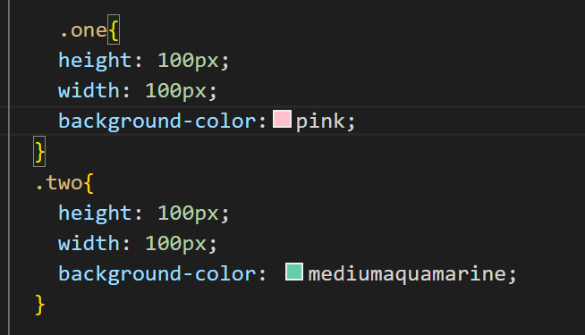

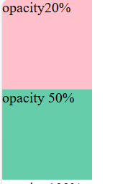

7• How can image repetition of the backup be controlled?

ANS: This task can be achieved by using the *background-repeat property* that will help us to control the repetition of the image.

The **background-repeat property** in CSS is used to repeat the background image both horizontally and vertically. It also decides whether the background image will be repeated or not.

**Syntax:**

background-repeat: repeat|repeat-x|repeat-y|no-repeat|initial|inherit;

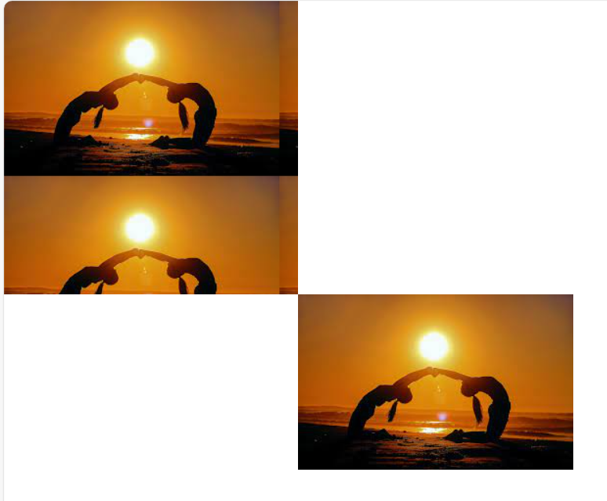

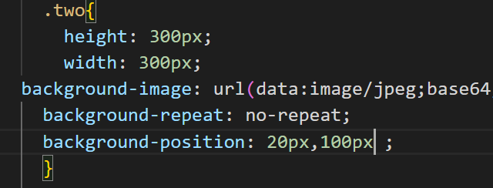

8 • What is the use of the background-position property?

ANS: The **background-position** property in CSS is mainly used to sets the initial position for the background image ie., it is used to set an image at a certain position. The position that is relative to the positioning layer, can be set by using the background-origin property.

**Syntax:**

background-position: value;

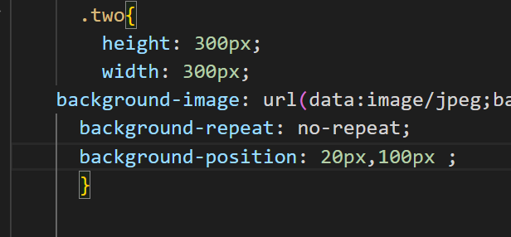

9 • Which property controls the image scroll in the background?

ANS:  we will discuss the property that is used to control the scrolling of an image in the background. The background-attachment property in CSS is used to specify the kind of attachment of the background image with respect to its container. It can be set to scroll or make it remain fixed. It can be applied to all html elements.

**Syntax:**

background-attachment: scroll|fixed|local|initial|inherit;

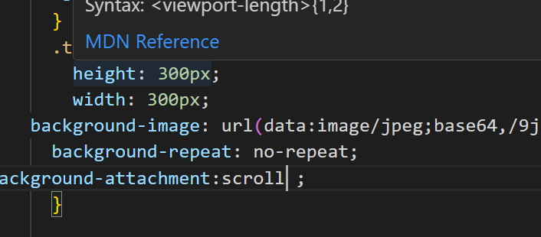

10• Why should background and color be used as separate properties?

ANS: background and color are separate properties because they can be used for different purposes. The background property is used to set the background color or image of an element, while the color property is used to set the text color of that element. These properties can be used together to create a cohesive design, but they can also be used separately to create different effects. For example, you might want to set a background color for an element but leave the text color as the default.

11 • How to center block elements using CSS1?

ans: The way to do that is to set the margins to 'auto'. This is normally used with a block of fixed width, because if the block itself is flexible, it will simply take up all the available width. Here is an example: P.blocktext { margin-left: auto; margin-right: auto; width: 8em }



12 • How to maintain the CSS specifications?

Ans: The CSS specifications are maintained by the World Wide Web Consortium (W3C).

13• What are the ways to integrate CSS as a web page?

Ans: CSS may be added to HTML in three different ways. To style a single HTML element on the page, use Inline CSS in a style attribute. By adding CSS to the head section of our HTML document, we can embed an internal stylesheet. We can also connect to an external stylesheet that separates our CSS from our HTML

14• What is embedded style sheets?

Ans: Embedded Stylesheet: It allows you to define styles for a particular HTML document as a whole in one place. This is done by embedding the <style></style> tags containing the CSS properties in the head of your document.

<!DOCTYPE html>  
<html>  
<head>  
<link rel="stylesheet" href="mystyle.css">  
</head>  
<body>  
  
<h1>This is a heading</h1>  
<p>This is a paragraph.</p>  
  
</body>  
</html>

15 • What are the external style sheets?

Ans: An external style sheet is a separate CSS file that can be accessed by creating a link within the head section of the webpage. Multiple webpages can use the same link to access the stylesheet. The link to an external style sheet is placed within the head section of the page.

16• What are the advantages and disadvantages of using external style sheets?

Ans:The advantages of External Style Sheets are as follows :

->With the help of External Style Sheets, the styles of numerous documents can be organized from one single file.

->In External Style Sheets, Classes can be made for use on numerous HTML element types in many forms of the site.

->In complex contexts, Methods like selector and grouping can be implemented to apply styles.

The disadvantages of External Style Sheets are as follows :

->An extra download is essential to import style information for each file.

->The execution of the file may be deferred till the external style sheet is loaded.

->While implementing style sheets, we need to test Web pages with multiple browsers in order to check compatibility issues.

17• What is the meaning of the CSS selector?

Ans: CSS selectors are used to "find" (or select) the HTML elements you want to style. We can divide CSS selectors into five categories: Simple selectors (select elements based on name, id, class) Combinator selectors (select elements based on a specific relationship between them)

18• What are the media types allowed by CSS?

Ans: Media queries can be used to check many things, such as:

width and height of the viewport

width and height of the device

orientation (is the tablet/phone in landscape or portrait mode?)

resolution

Using media queries are a popular technique for delivering a tailored style sheet (responsive web design) to desktops, laptops, tablets, and mobile phones.

You can also use media queries to specify that certain styles are only for printed documents or for screen readers (mediatype: print, screen, or speech).

In addition to media types, there are also media features. Media features provide more specific details to media queries, by allowing to test for a specific feature of the user agent or display device. For example, you can apply styles to only those screens that are greater, or smaller, than a certain width.

19• What is the rule set?

Ans: A CSS rule set contains one or more selectors and one or more declarations. The selector(s), which in this example is h1 , points to an HTML element. The declaration(s), which in this example are color: blue and text-align: center style the element with a property and value.